AWS IAM USER & EC2 PROJECT

Step 1 — Specify IAM User Details
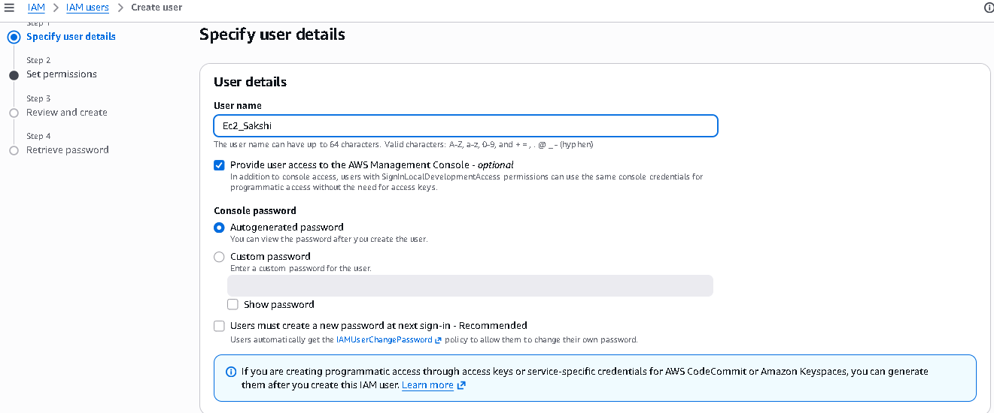

Step 2 — Set IAM User Permissions
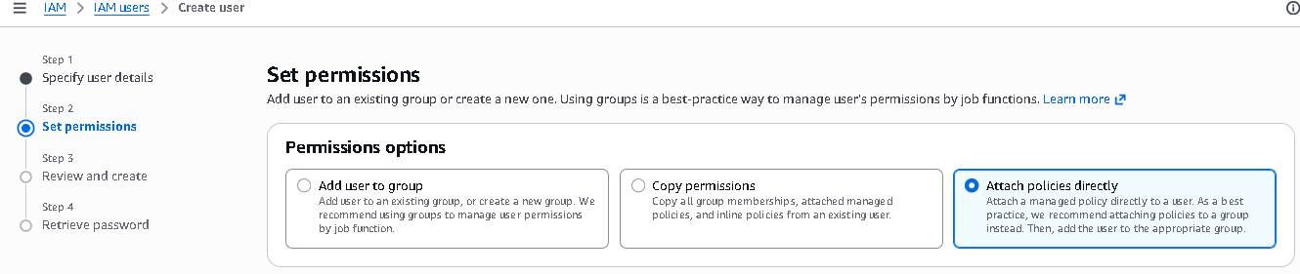

Step 3 — Select IAM Permissions Policy
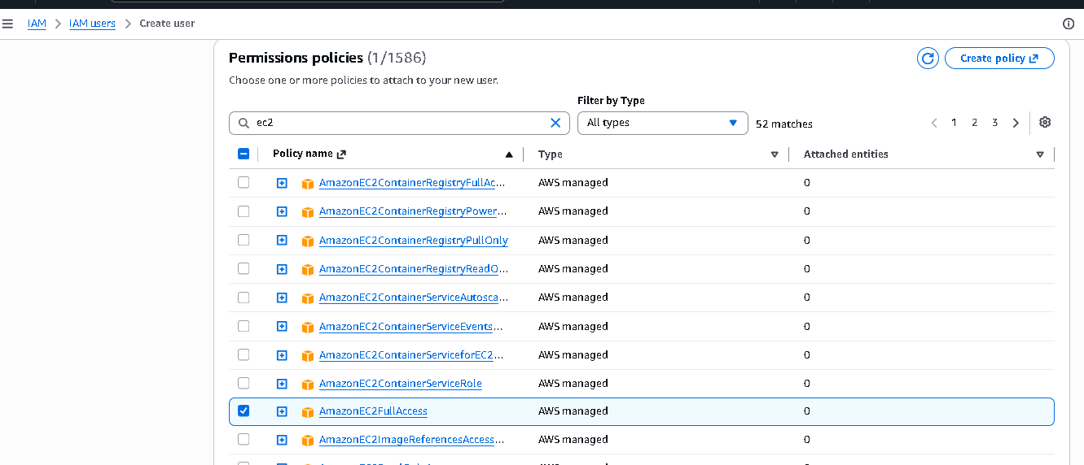

Step 4 — Review and Create IAM User
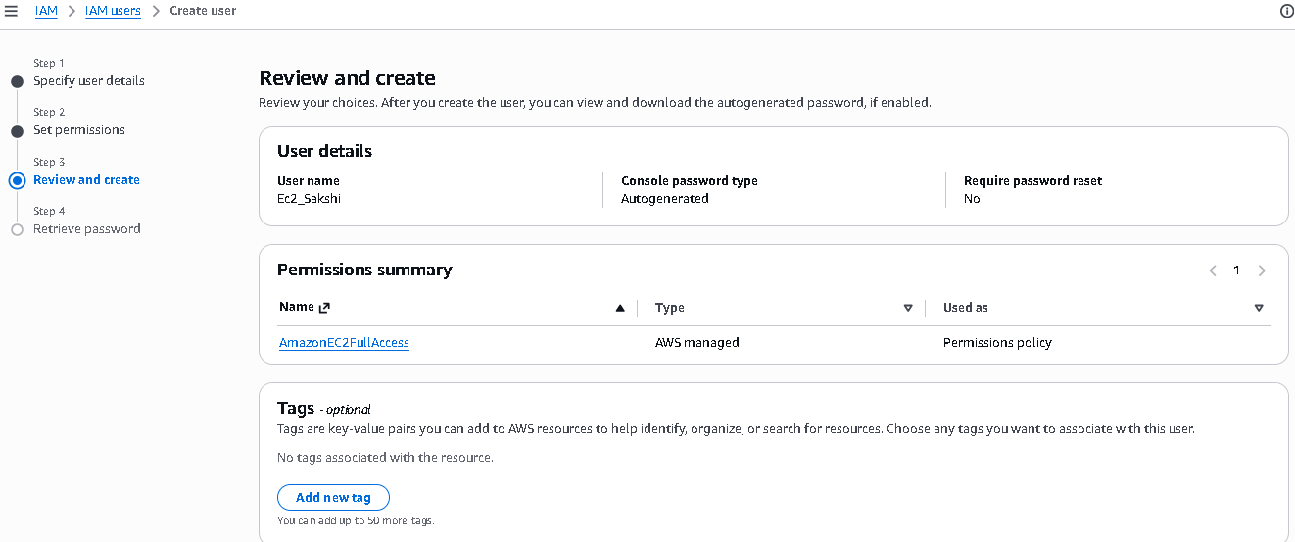

Step 5 — Retrieve IAM User Password
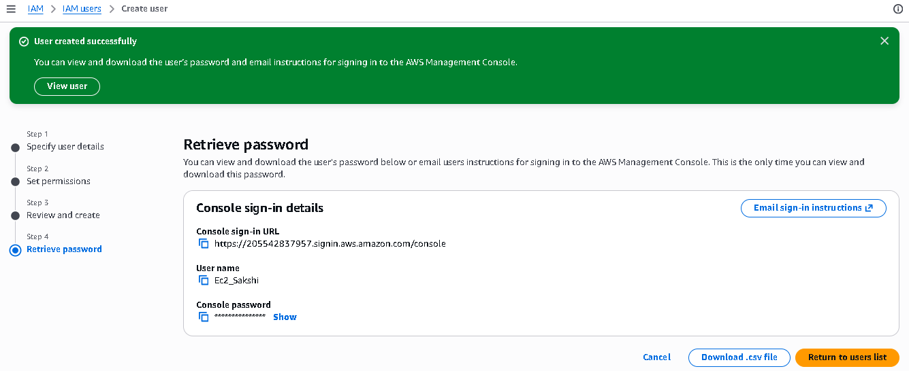

Step 6 — Sign In to AWS Management Console

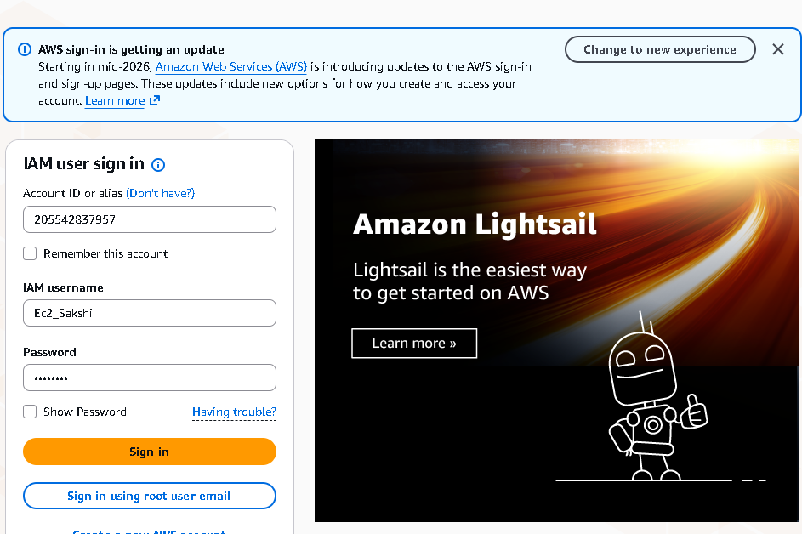
Step 7 — Open Amazon EC2 Dashboard
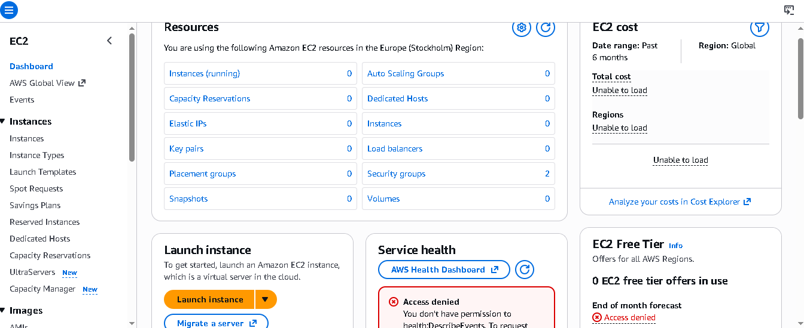

Step 8 — Launch an EC2 Instance and Enter Its Name
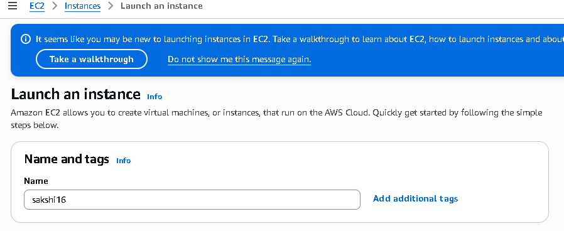

Step 9 — Select Amazon Machine Image (AMI)
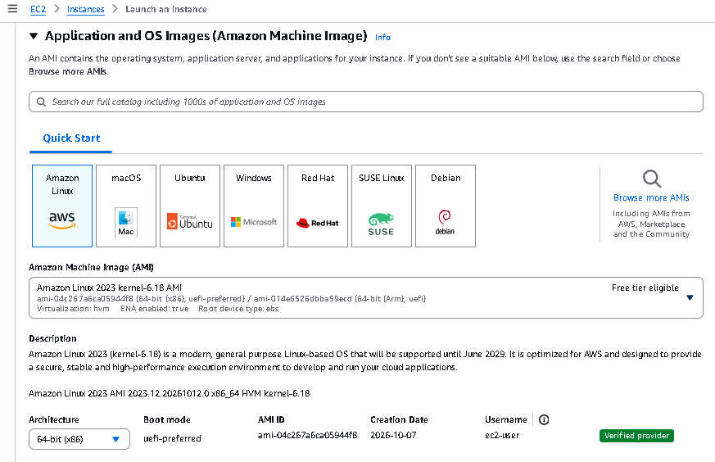

Step 10 — Choose EC2 Instance Type
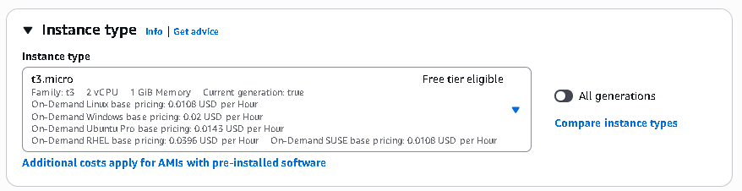

Step 11 — Configure Key Pair (Login)
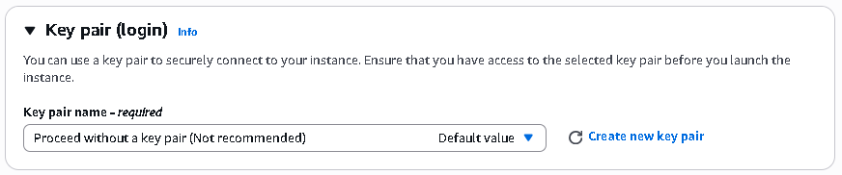

Step 12 — Configure Network Settings
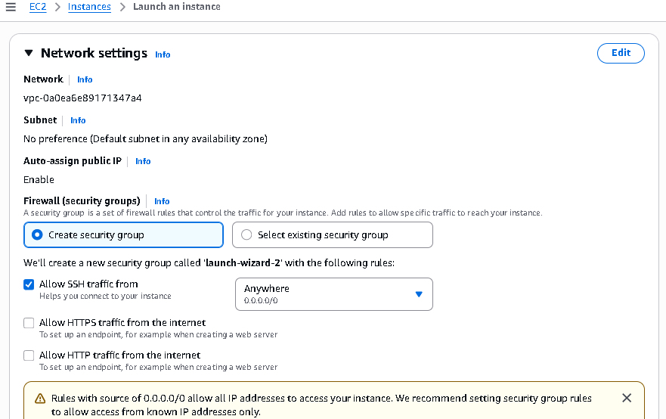

Step 13 — Configure Instance Storage
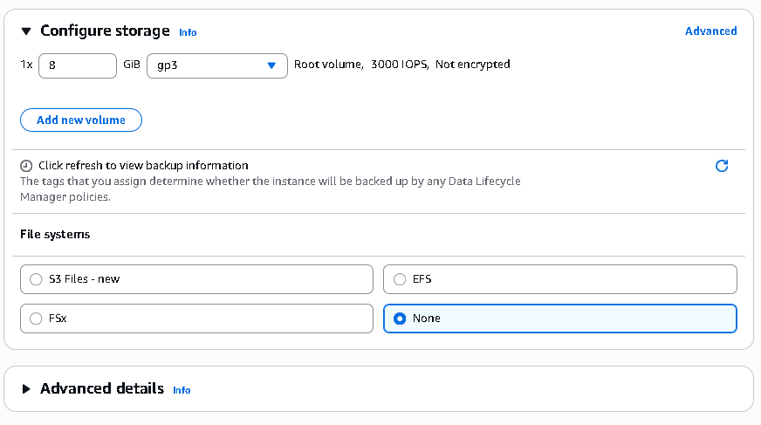

Step 14 — Review Instance Configuration
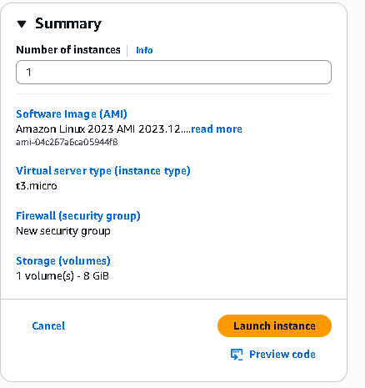

Step 15 — Launch the EC2 Instance
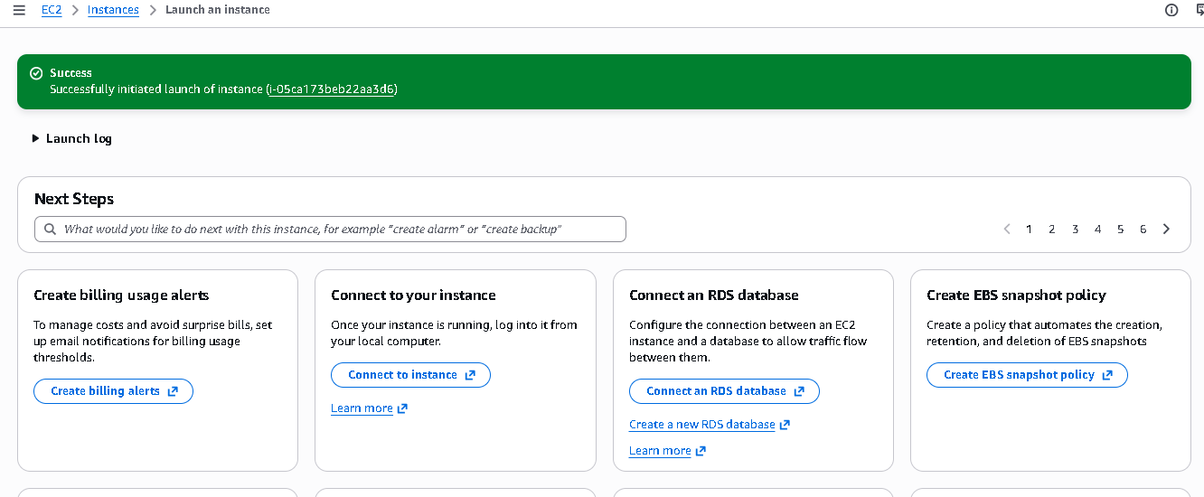

Step 16 — Verify the EC2 Instance in the Instances List
